Ukpik-1

*Custom Boards*

REVISION NUMBER: *0.1*

DATE: *2020-09-20*

COMPILED BY: *Handong Cheng*

CONTRIBUTIONS FROM:  *Nicholas Mitchell*

**Document Change Record**

|  |  |  |  |
| --- | --- | --- | --- |
| Issue | Date | Changes Made | Name |
| 0.1 | 2020-09-20 | First Draft | Cheng, Handong |
| 0.2 | 2020-10-04 | Second Draft | Nicholas Mitchell |
|  |  |  |  |

**Reference Documents**

*Insert applicable reference document titles, such as requirements documents*

**Terms, Definitions, Abbreviations**

|  |  |
| --- | --- |
| CSA | Canadian Space Agency |
|  |  |
|  |  |
|  |  |
|  |  |

Contents

Requirements 1

Architecture and Interface Diagrams 1

Functional Operations 1

Manufacturing, Procurement, Assembly, and Integration Plan 1

Test and Verification Plan 1

Schedule and Work Plan for Phase C2 and D 2

Datasheets for COTS Components 2

# Requirements

|  |  |  |
| --- | --- | --- |
| **Requirement ID** | **Requirements Description** | **Resources** |
| ELC-01 | All electrical power storage devices must be internal to the CubeSat | 4.2.1.1 |
| ELC-02 | CubeSat must not operate any system (including RF transmitters, deployment mechanisms or otherwise energize the main power system) for a minimum of 30 minutes where hazard potential exists. Satellites must have a timer (set to a minimum of 30 minutes and require appropriate fault tolerance) before satellite operation or deployment of appendages where hazard potential exists | 4.2.1.2 |
| ELC-03 | The CubeSat electrical system design must incorporate a minimum of three (3) independent inhibit switches actuated by physical deployment switches as shown in Figure 4.2-1. The satellite inhibit scheme must include a ground leg inhibit (switch D3 on Figure 4.2-1) that disconnects the batteries along the power line from the negative terminal to ground. | 4.2.1.3 |
| ELC-04 | The CubeSat electrical system design must not permit the ground charge circuit to energize the satellite systems (load), including flight computer (see Figure 4.2-1). This restriction applies to all charging methods | 4.2.1.4 |
| ELC-05 | The CubeSat must have a remove before flight (RBF) feature or an apply before flight (ABF) feature that keeps the satellite in an unpowered state throughout the ground handling and integration process into the NRCSD. | 4.2.1.5 |
| ELC-06 | The RBF /ABF feature must preclude any power from any source operating any satellite functions with the exception of pre-integration battery charging. | 4.2.1.6 |
| ELC-07 | The CubeSat Electrical Power System (EPS) must have no more than six (6) inches of wire 26AWG or larger between the power source (i.e. battery pack) and the first electrical inhibit. | 4.2.1.7 |
| ELC-08 | There must be no electrical or data interfaces between the CubeSat and the NRCSD. As outlined in Section 4.2, the CubeSat must be completely inhibited while inside the NRCSD | 4.2.2.1 |
| ELC-09 | All spacecraft components must be electrically bonded per SSP 30245 to ensure the spacecraft is free from electrical shock and static discharge hazards. Typically, spacecraft components may be bonded by either nickel plating or chemical film treated faying surfaces or dedicated bonding straps. | 4.4.11.1 |
| ELC-10 | The software protocols used to connect the OBC to the other subsystems must be simulated without issue | SYS-ELC-010 |
| ELC-11 | Electrical components must be tested to the standards at which they are specified in the sub-system requirements or hardware data sheets | SYS-ELC-020 |
| ELC-12 | The satellite must receive power from ground systems for charging, stand-alone testing or prior to switching to internal power sources for testing | SYS-ELC-030 |
| ELC-13 | The CubeSat must pass the functional component tests as outlined in the CubeSat Test Plan [AD9] | SYS-ELC-040 |
| ELC-14 | Dissimilar metals in contact must not generate an electromotive force of more than 0.5V (TBC) | SYS-ELC-050 |
| ELC-15 | Isolated conductors such as connector pins and radiation spot shields must be grounded as follows: a) Isolated conductors located on or near the surface of the spacecraft to be grounded to the structure with less than 10 6 ohms so as to prevent surface charging b) Isolated conductors located inside the spacecraft structure to be grounded to the structure with less than 10 12 ohms so as to prevent internal charging | SYS-ELC-060 |
| ELC-16 | Antenna pattern testing must be performed to verify the antenna pattern for the fully assembled micro-satellite | SYS-ELC-070 |
| ELC-17 | Each subsystem must be tested independently prior to unit assembly. | SYS-ELC-080 |
| ELC-18 | TheCubeSat must pass electric field Radiated Emission (RE) testing as per the following specifications and defined in [AD4]. Frequency range from 30 MHz to 1 GHz and a limit of 50 dBμV/m at all frequencies | SYS-ELC-080 |
| ELC-19 | The CubeSat should pass B Field testing as per the following specifications and defined in [AD4]. DC Frequency Range and a limit of 0.2 μT at 1m distance from each face | SYS-ELC-081 |
| ELC-20 | The CubeSat should pass electric field Radiated Susceptibility (RS) testing as per the following specifications and defined in [AD4]. Frequency Range of 30 MHz to 10 GHz, 10 V/m outside the main frame or at proximity of beams, and 1 V/m inside the main frame | SYS-ELC-090 |
| SY-SS04 | The CubeSat must have deployment switches | MR-OP06 |
| SY-SS05 | The CubeSat must have a 30-minute timer circuit | MR-OP06 |
| SY-SS18 | The CubeSat shall survive the low earth orbit radiation environment | MR-OP04, MR-OP05 |
| SY-SS11 | The CubeSat shall control its pose | MR-OP01 |
| SY-SS25 | The CubeSat components shall be designed or selected to prevent undesired electromagnetic effects | MR-OP04 |
| SY-SS29 | The CubeSat transition to Deployment Mode shall trigger a 30 minute timer. | MR-PR07, MR-OP06 |
| SY-SS31 | The CubeSat shall deploy its antenna following the 30 minute delay | MR-PR07, MR-OP06 |
| SY-SS77 | Test connectors must be provided with a metallic blanking cover providing a continuous electrical shield over the connector for flight to prevent radiation at the interface and to protect the contacts from damage or false connection | SYS-INT-033 |
| SY-SS78 | The CubeSat must incorporate an umbilical connector easily accessible to allow battery charging and basic functional verification of the space craft during ground testing and pre-launch operations | SYS-INT-040 |

# Architecture and Interface Diagrams

Custom Board 1 Block Diagram:

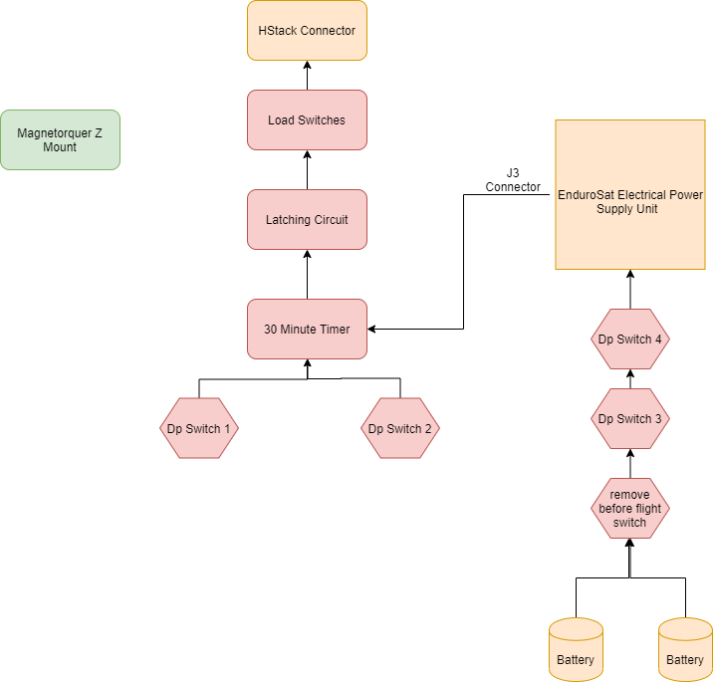

Custom board 1 Microcap Diagram for Timer Circuit (without inhib switches):

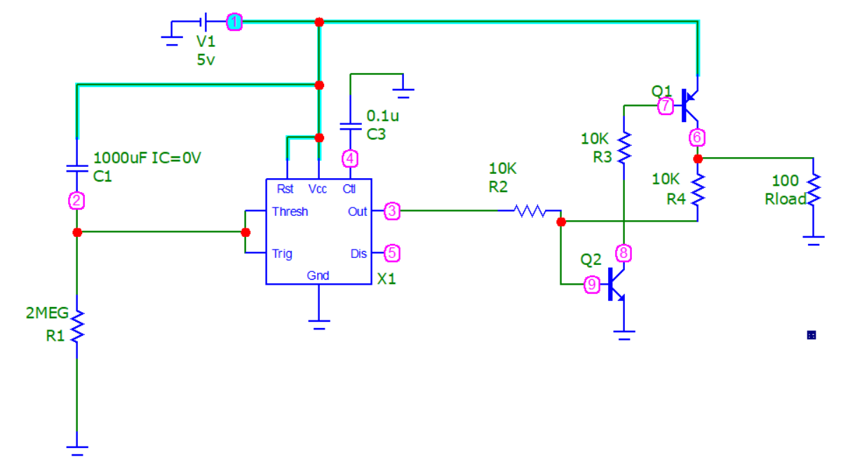

Microcap Simulation transient analysis:

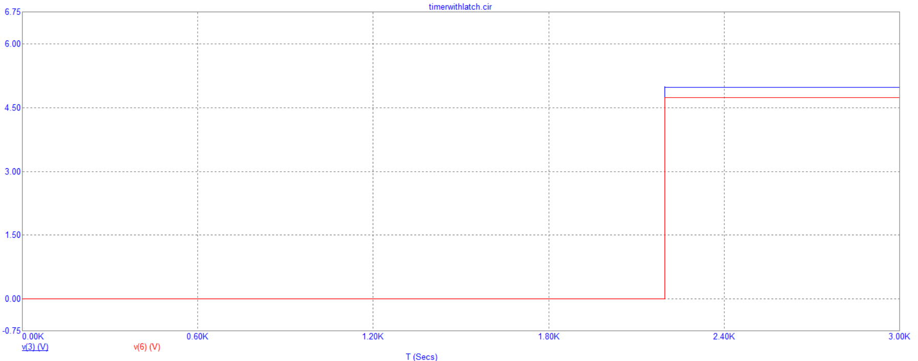

Custom board 1 Microcap Diagram(with inhib switches)

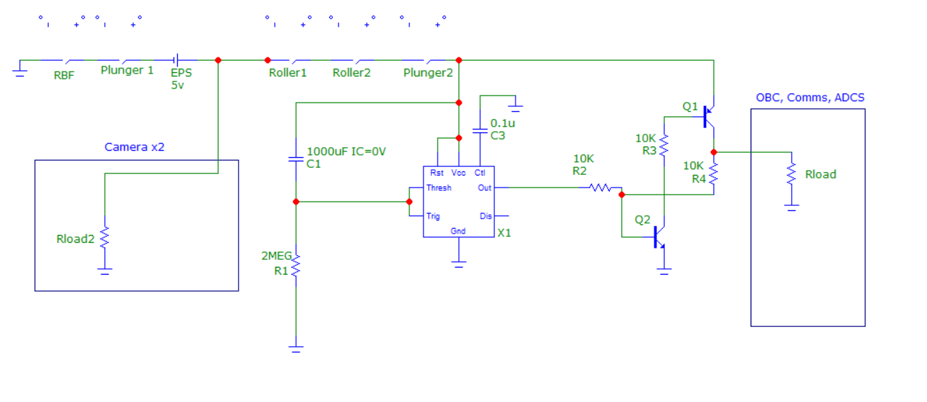

Custom board 1 Microcap Diagram for Timer Circuit(Inhib Switch simulation Ground leg Disconnected):

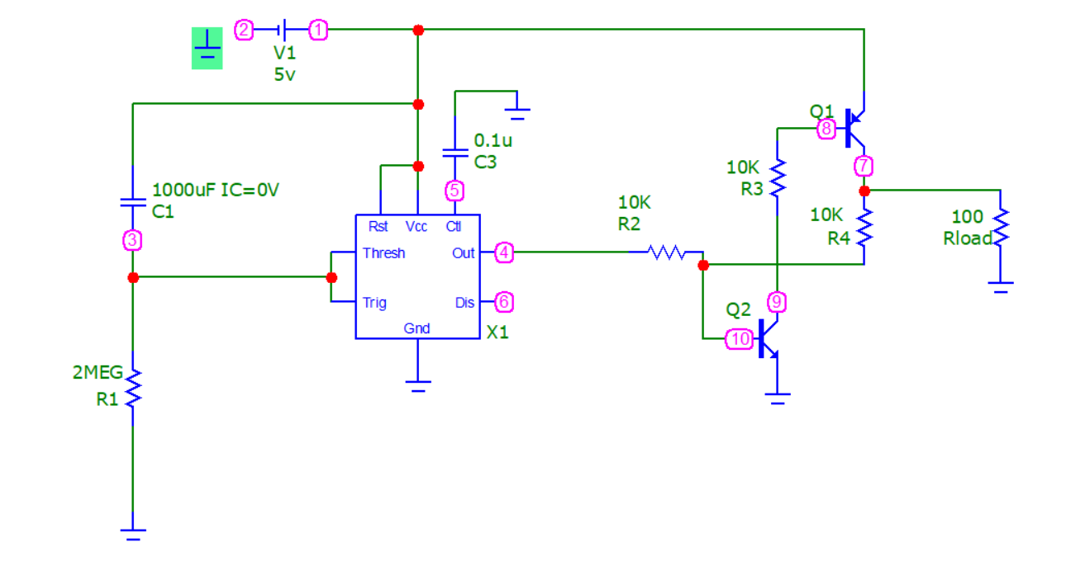

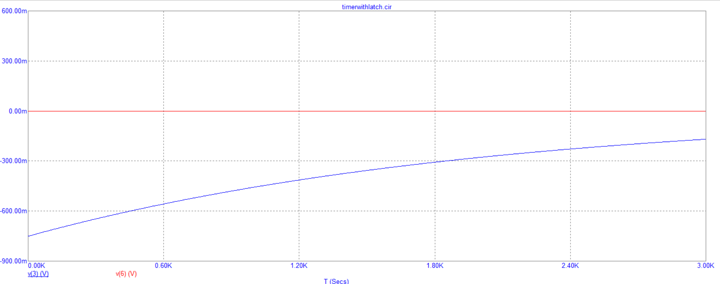

Custom board 1 Microcap Diagram for Timer Circuit(Reset Pins):

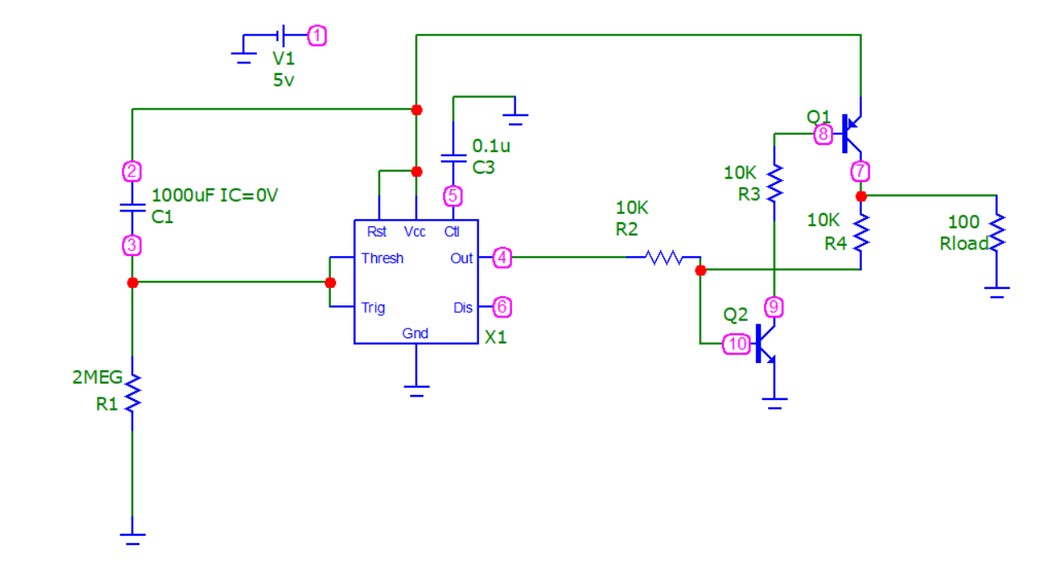

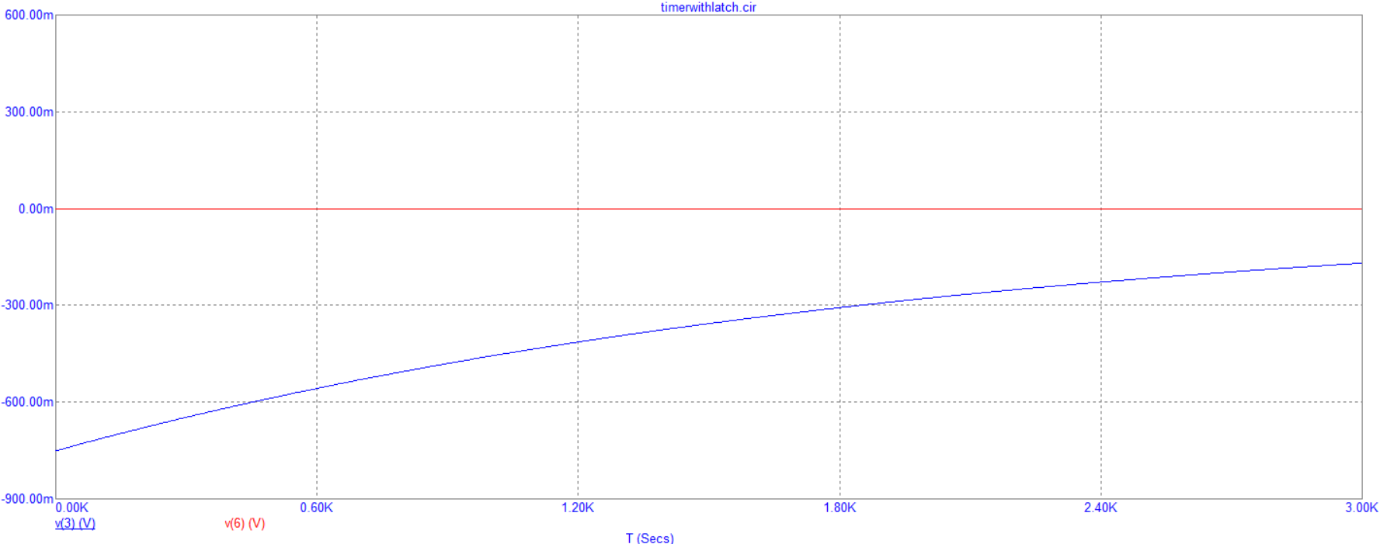

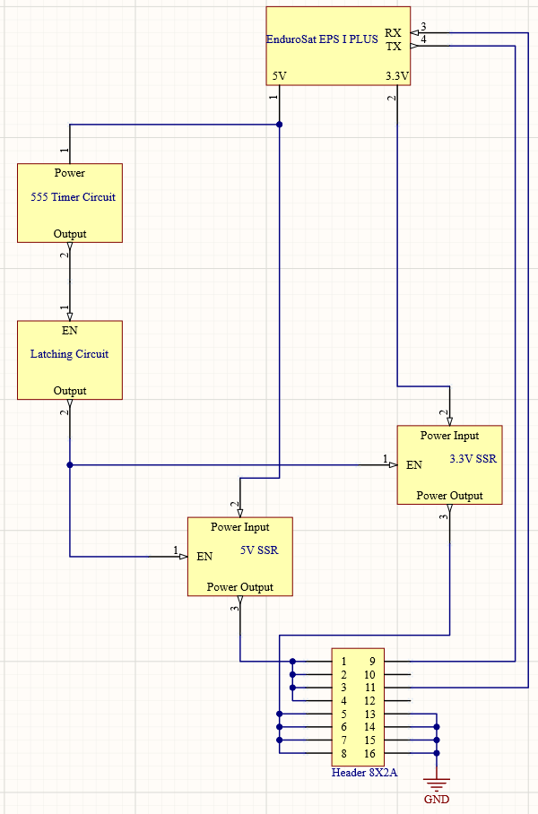Custom Board 1 Block Diagram:

Custom Board 1 PCB Schematic Sections:

H-Stack

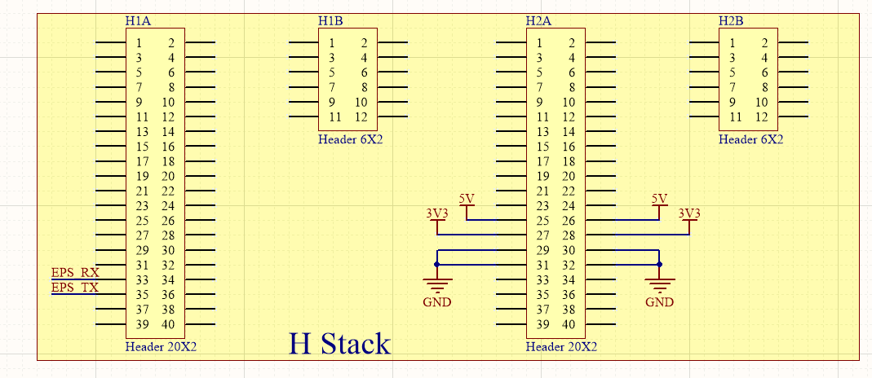

Deployment Switches and 30 minute Timer:

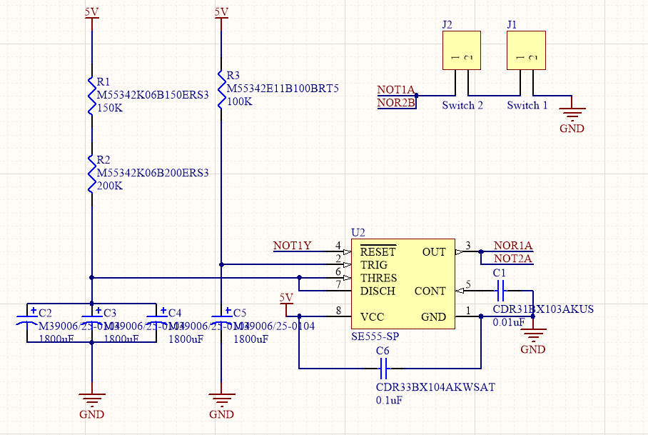

Latching Circuit:

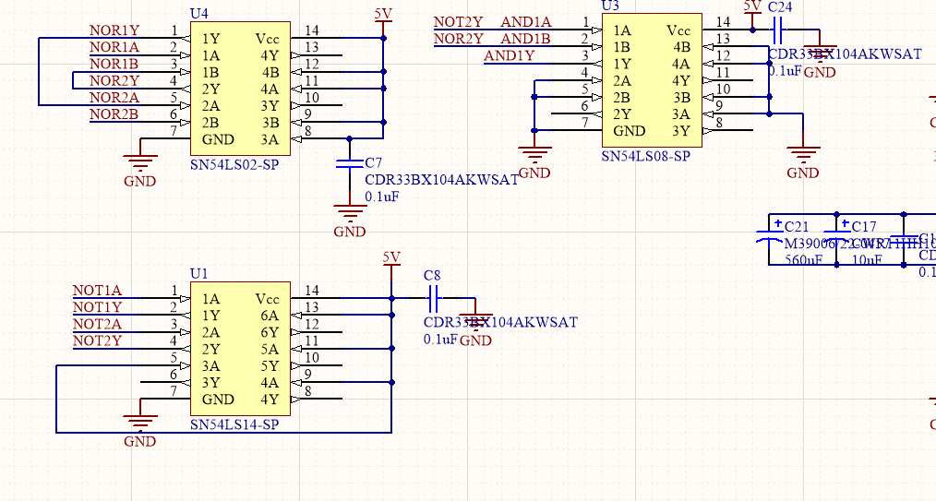

Fuse Protection:

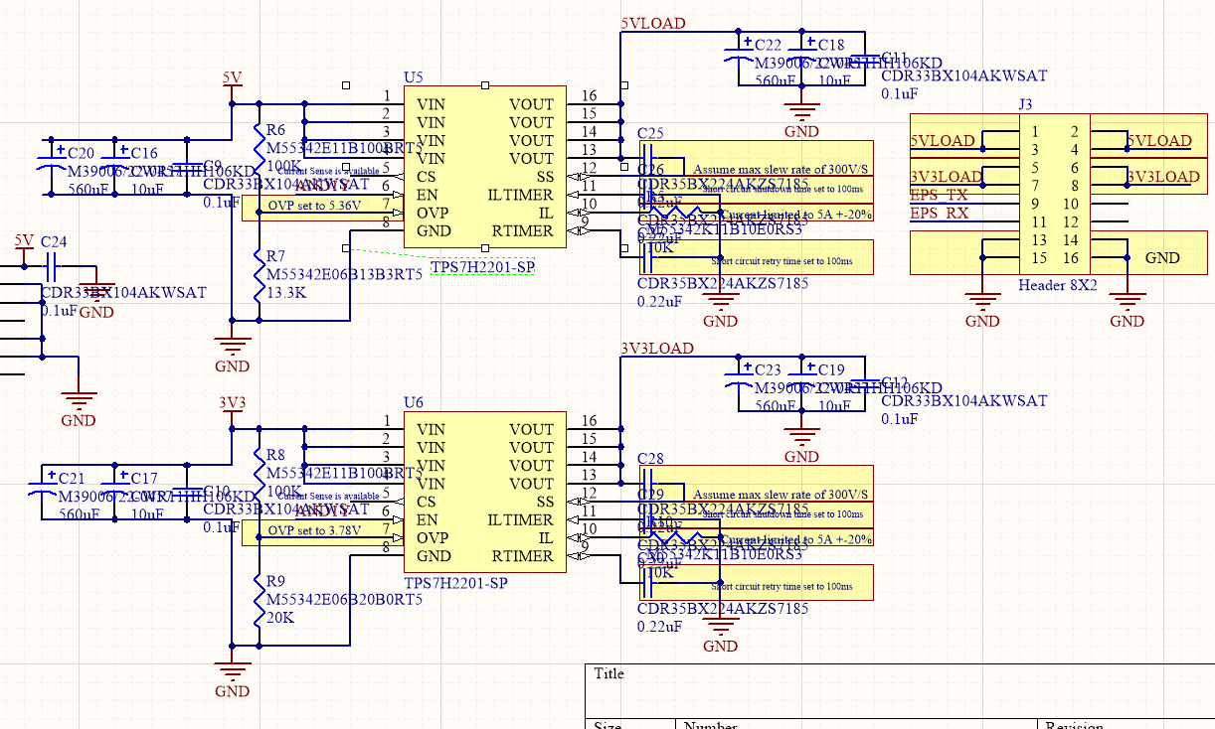

# Functional Operations

Launch Mode (no power is supplied to subsystems)

Remove of the RBF and activation of deployment switches

Deployment Mode ( 30 minutes timer starts, only the payload(?) and timer circuit are powered)

30 minutes after entering deployment mode

Detumble Mode ( Deploy antennas, all subsystems are powered)

3D View Custom board 1 PCB Top

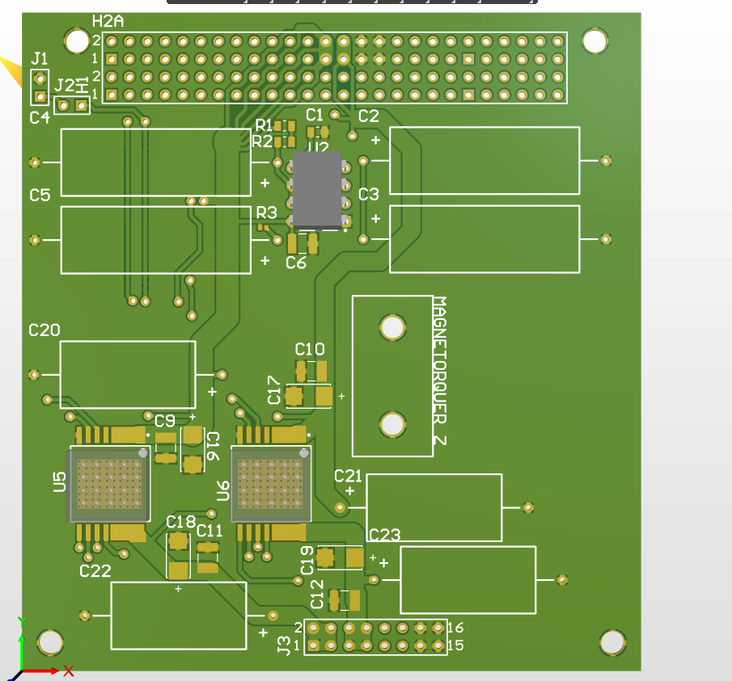

3D-View Custom board 1PCB Bottom

# 

Note* White line area is to indicate where the all SMD devices and IC’s must be place inside of. There is a lot of mechanical support area underneath the board. Our current iteration is a 2 layer board, we will need to move toa 4 layer board to see if we can get all IC’s inside the box or iterate through having less area for the mechanical support.

Custom Board 2 Block Diagram:

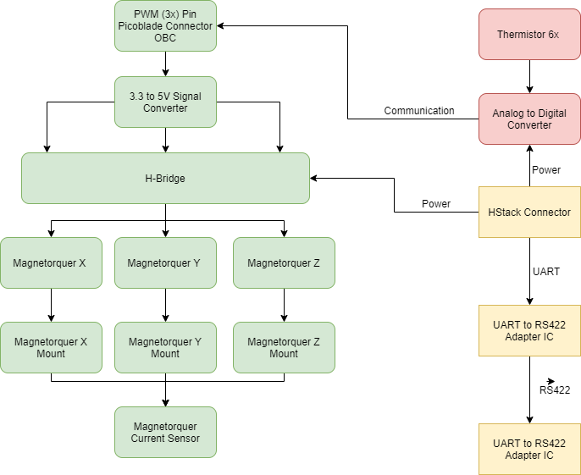

Custom Board 1 PCB Bottom view:

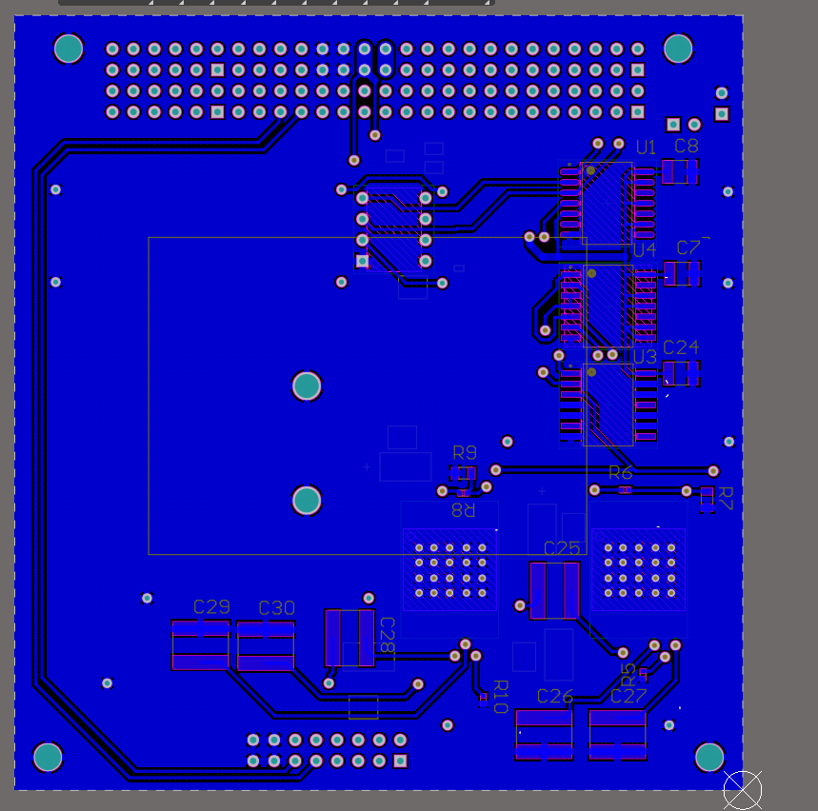

Custom Board 1 PCB Top view:

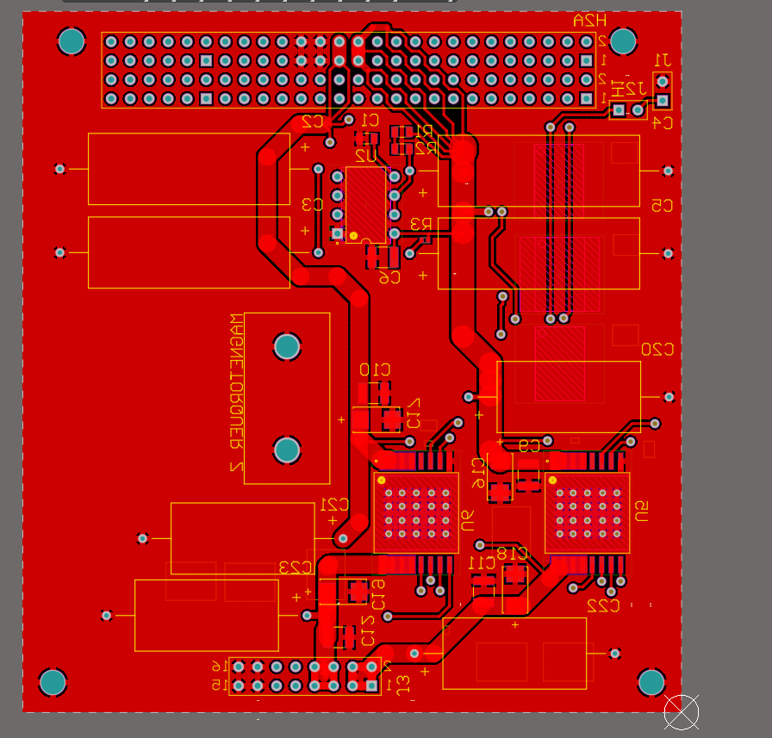

# Custom Board 2 Design

Magnetorquer control:

OBC PWM pins output 3.3 V at maximum 3 A, However magnetorquer control law was designed with 5V source. Need a 3.3 to 5V converter at decently high current(120mA).

|  |  |  |
| --- | --- | --- |
| Power | 600 | mW |
| Voltage | 5 | V |
| Current | 0.1200 | A |
| Required Resistance of Coil | 41.67 | Ω |
|  |  |  |
| Length of Coil | 101.067 | m |
| resistivity of wire | 1.68E-08 | Ωm |
| Diameter of Wire | 0.0002305 | m |
| Area of wire | 4.17284E-08 | m^2 |
| Resistance of Coil | 40.69 | Ω |
|  |  |  |
| Length of Coil | 76.26 | m |
| resistivity of wire | 1.68E-08 | Ωm |
| Diameter of Wire | 0.0002305 | m |
| Area of wire | 4.17284E-08 | m^2 |
| Resistance of Coil | 30.70 | Ω |

**Load switch vs Discreet Mosfet Implementation:**

Background information on load switch vs. MOSFET implementation. <https://www.ti.com/lit/an/slva652a/slva652a.pdf?ts=1601051284970>

Trade-off is that load switches are small but more expensive. Since we are struggling for board space this is the better implementation (if we can find a suitable load switch.)

**Load switch vs BJT Control:**

Load switch has inrush current limiting protection

Tolerance analysis will be easier with load switch, guaranteed data on its performance

Low quiescent current with load switch (draws less power in standby)

Load switch is the preferred method of switching for the Transistors:

Chosen load switch:

<https://www.renesas.com/us/en/products/space-harsh-environment/rad-hard-power/rh-load-switches/device/ISL73061SEH.html#overviewInfo>

dimensions: 9.91 x 23.45 x 2.92 mm

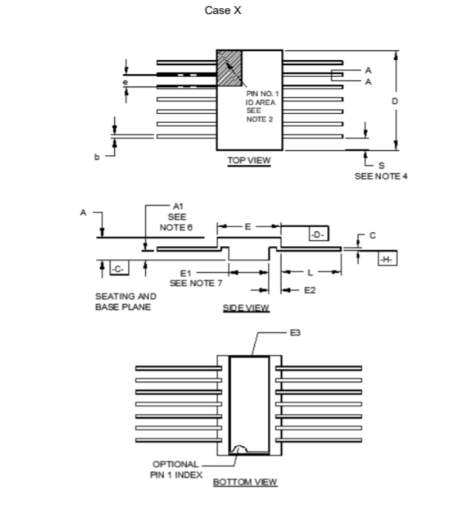

**Main question:**

**Does magnetorquer control require current to flow both ways through the torque rods?**

**It is difficult to find a space rated IC for an H-bridge. Is there any good location or do we have to implement ourselves?**

If yes: H-bridge is needed

If no: Eliminate H-bridge from design

Background information for H-bridge control:

<http://folk.ntnu.no/tomgra/Diplomer/Rein.pdf>

<http://cubesat.ece.illinois.edu/files/acs_bryan_gregory_thesis.pdf>

https://courses.engr.illinois.edu/ece445/getfile.asp?id=16327

page 59

<https://courses.engr.illinois.edu/ece445/getfile.asp?id=16327>

<https://www.eucass.eu/doi/EUCASS2017-660.pdf>

<https://scholarworks.uark.edu/cgi/viewcontent.cgi?article=1074&context=meeguht>

# Manufacturing, Procurement, Assembly, and Integration Plan

At the moment, the manufacturer of the PCB has not been decided. (this means that trace size is still variable).

Majority of the components are available via Digi-key and Mouser. Special space rated components can be obtained by contacting the manufacturer of the components.

The assembly of the prototype PCB may be done with hand soldering.

# Test and Verification Plan

*Not yet complete. Inserted requirements again as a place holder.*

|  |  |  |
| --- | --- | --- |
| **Requirement ID** | **Requirements Description** | **Resources** |
| ELC-01 | All electrical power storage devices must be internal to the CubeSat | 4.2.1.1 |
| ELC-02 | CubeSat must not operate any system (including RF transmitters, deployment mechanisms or otherwise energize the main power system) for a minimum of 30 minutes where hazard potential exists. Satellites must have a timer (set to a minimum of 30 minutes and require appropriate fault tolerance) before satellite operation or deployment of appendages where hazard potential exists | 4.2.1.2 |
| ELC-03 | The CubeSat electrical system design must incorporate a minimum of three (3) independent inhibit switches actuated by physical deployment switches as shown in Figure 4.2-1. The satellite inhibit scheme must include a ground leg inhibit (switch D3 on Figure 4.2-1) that disconnects the batteries along the power line from the negative terminal to ground. | 4.2.1.3 |
| ELC-04 | The CubeSat electrical system design must not permit the ground charge circuit to energize the satellite systems (load), including flight computer (see Figure 4.2-1). This restriction applies to all charging methods | 4.2.1.4 |
| ELC-05 | The CubeSat must have a remove before flight (RBF) feature or an apply before flight (ABF) feature that keeps the satellite in an unpowered state throughout the ground handling and integration process into the NRCSD. | 4.2.1.5 |
| ELC-06 | The RBF /ABF feature must preclude any power from any source operating any satellite functions with the exception of pre-integration battery charging. | 4.2.1.6 |
| ELC-07 | The CubeSat Electrical Power System (EPS) must have no more than six (6) inches of wire 26AWG or larger between the power source (i.e. battery pack) and the first electrical inhibit. | 4.2.1.7 |
| ELC-08 | There must be no electrical or data interfaces between the CubeSat and the NRCSD. As outlined in Section 4.2, the CubeSat must be completely inhibited while inside the NRCSD | 4.2.2.1 |
| ELC-09 | All spacecraft components must be electrically bonded per SSP 30245 to ensure the spacecraft is free from electrical shock and static discharge hazards. Typically, spacecraft components may be bonded by either nickel plating or chemical film treated faying surfaces or dedicated bonding straps. | 4.4.11.1 |
| ELC-10 | The software protocols used to connect the OBC to the other subsystems must be simulated without issue | SYS-ELC-010 |
| ELC-11 | Electrical components must be tested to the standards at which they are specified in the sub-system requirements or hardware data sheets | SYS-ELC-020 |
| ELC-12 | The satellite must receive power from ground systems for charging, stand-alone testing or prior to switching to internal power sources for testing | SYS-ELC-030 |
| ELC-13 | The CubeSat must pass the functional component tests as outlined in the CubeSat Test Plan [AD9] | SYS-ELC-040 |
| ELC-14 | Dissimilar metals in contact must not generate an electromotive force of more than 0.5V (TBC) | SYS-ELC-050 |
| ELC-15 | Isolated conductors such as connector pins and radiation spot shields must be grounded as follows: a) Isolated conductors located on or near the surface of the spacecraft to be grounded to the structure with less than 10 6 ohms so as to prevent surface charging b) Isolated conductors located inside the spacecraft structure to be grounded to the structure with less than 10 12 ohms so as to prevent internal charging | SYS-ELC-060 |
| ELC-16 | Antenna pattern testing must be performed to verify the antenna pattern for the fully assembled micro-satellite | SYS-ELC-070 |
| ELC-17 | Each subsystem must be tested independently prior to unit assembly. | SYS-ELC-080 |
| ELC-18 | TheCubeSat must pass electric field Radiated Emission (RE) testing as per the following specifications and defined in [AD4]. Frequency range from 30 MHz to 1 GHz and a limit of 50 dBμV/m at all frequencies | SYS-ELC-080 |
| ELC-19 | The CubeSat should pass B Field testing as per the following specifications and defined in [AD4]. DC Frequency Range and a limit of 0.2 μT at 1m distance from each face | SYS-ELC-081 |
| ELC-20 | The CubeSat should pass electric field Radiated Susceptibility (RS) testing as per the following specifications and defined in [AD4]. Frequency Range of 30 MHz to 10 GHz, 10 V/m outside the main frame or at proximity of beams, and 1 V/m inside the main frame | SYS-ELC-090 |
| SY-SS56 | The CubeSat subsystems must be constructed enturely of EEE grade 3 parts or better (TBC) | SYS-GEN-010 |
| SY-SS57 | All CubeSat components must be marked with model numbers | SYS-GEN-020 |
| SY-SS60 | All CubeSat components must be marked with a serial number | SYS-GEN-023 |
| SY-SS61 | All CubeSat components must be designed to avoid open voltage sources | SYS-GEN-030 |
| SY-SS62 | All CubeSat components must not have electromagnetic emmisions generating interferences with other sybsystems/components | SYS-GEN-040 |
| SY-SS75 | Connectors must have gold-plated contacts and non-magnetic conductive metallic shells | SYS-INT-031 |
| SY-SS77 | Test connectors must be provided with a metallic blanking cover providing a continuous electrical shield over the connector for flight to prevent radiation at the interface and to protect the contacts from damage or false connection | SYS-INT-033 |
| SY-SS78 | The CubeSat must incorporate an umbilical connector easily accessible to allow battery charging and basic functional verification of the space craft during ground testing and pre-launch operations | SYS-INT-040 |

# Schedule and Work Plan for Phase C2 and D

|  |  |  |
| --- | --- | --- |
| **Task Description** | **Estimation of Time and Human Resources** | **Required Resources to Complete** |
| Rework Custom board 1 to fit components inside the allotted space | 30-40 hours, Boards team | Altium |
| Custom board 2 design and components selection | 40-50 hours, Boards team | Altium  Microcap/HSPICE  Excel  Word |
| Custom board 2 Breadboard model | 20 hours | Multimeter  Power Supply  PCB IC’s |
| Custom board 2 pcb design | 50 hours | Altium |
|  |  |  |
|  |  |  |
|  |  |  |

*Provide a description of the work that remains to be completed to complete the detailed design process. Provided an estimated time required to complete that work. Provide an estimate on the time and schedule for completing the testing, verification, assembly, and integration.*

# Datasheets for COTS Components

*Load switch for magnetorquer control:*

[*https://www.renesas.com/us/en/products/space-harsh-environment/rad-hard-power/rh-load-switches/device/ISL73061SEH.html#overviewInfo*](https://www.renesas.com/us/en/products/space-harsh-environment/rad-hard-power/rh-load-switches/device/ISL73061SEH.html#overviewInfo)